Chinqually Booters SC and TC United Shopping Event

November 17th 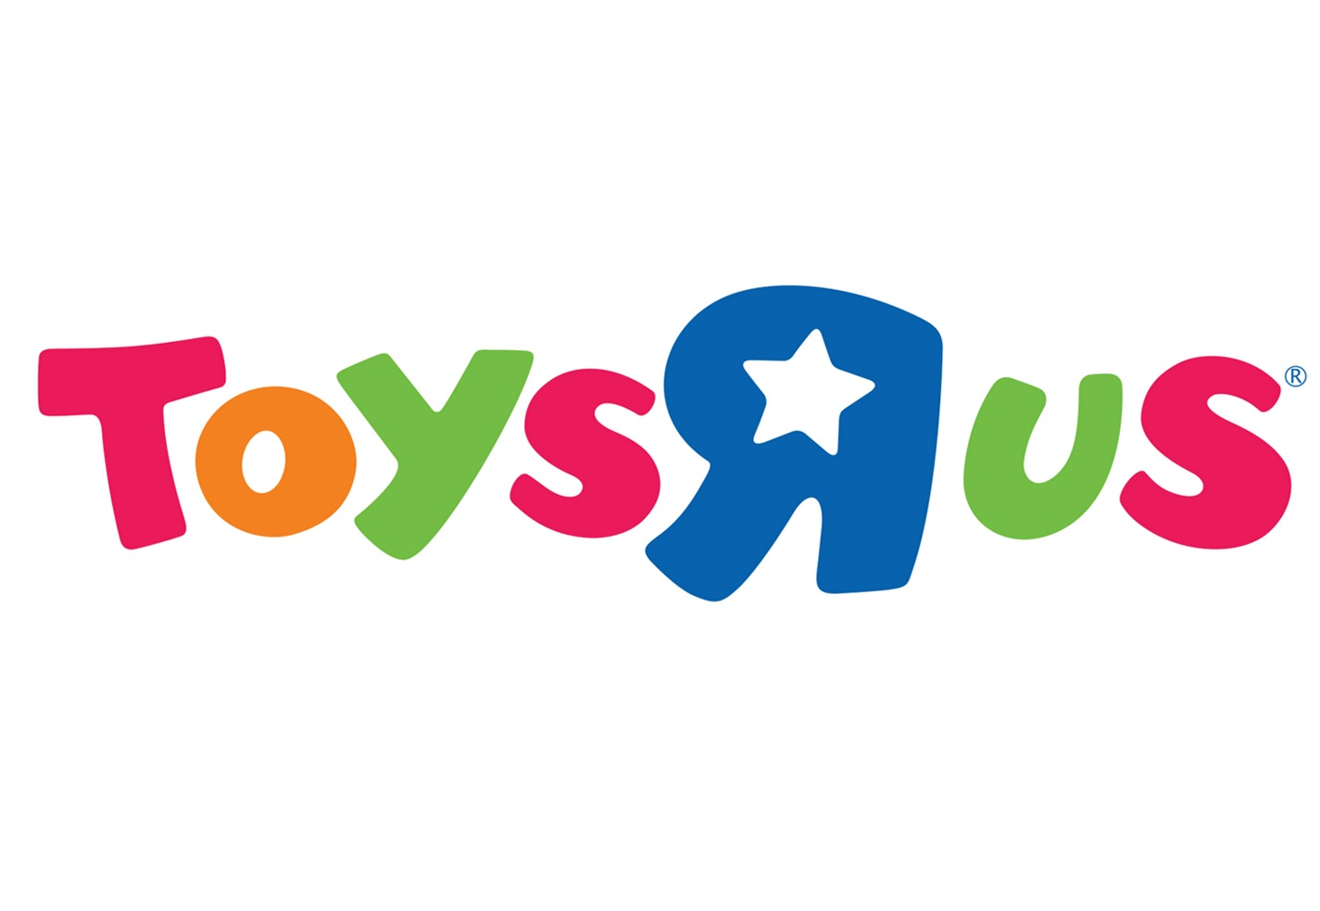

9:00AM to Midnight

1000 Cooper PT RD Olympia WA 98502
Olympia Toys “R” Us is excited to offer a one day shopping event for all CBSC and TCU families. On this day all families will be able to save an additional percentage off their purchases. All you need to do is show this flyer to your cashier to receive your savings.
$0-$150 receive 10% off
$150.01-$300 receive 15% off
$300.01 and Up receive 20% off
We will also have a raffle for two great gifts! One raffle ticket per family. Tickets will be handed out at checkout.

